
Lab #8 Summer 2017

60-212 OOP Using Java

School of Computer Science,

University of Windsor

Due: Monday, July 17th, 2017 at noon.

Note: To submit your assignment (and all other assignments/labs), create a zip with all source files (.java, NOT .bin!!) and any other necessary files (for instance, input files), and submit it on Blackboard. If the solution is only one file, zipping is not necessary. You will also demo your solution in lab, to the GA or to me. You will only receive a grade if you submit the solution online (on time) AND demo it in lab. If you fail to do either, you will receive zero.

10 Marks, 1% of grade

In this lab, you will create a GUI application that allows a user to move and resize a rectangle on the screen. The rectangle is initially red. If the user drags the top or left side of the rectangle, the rectangle should turn green and move with the mouse cursor. Movement should stop when the mouse is released, and the rectangle should go back to its original red colour. If the user drags the bottom or right side of the rectangle, the rectangle should turn blue and be resized using the edge being dragged. You need not handle a case where the bottom edge is dragged through the top edge, or the right edge is dragged through the left edge. When the mouse is released, resizing should stop and the mouse should go back to its original red colour. I have provided some code to get you started.

Screenshots:

Original configuration, and while mouse button is not held down:

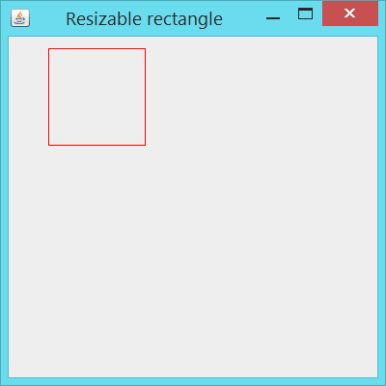

During a drag of top or left side:

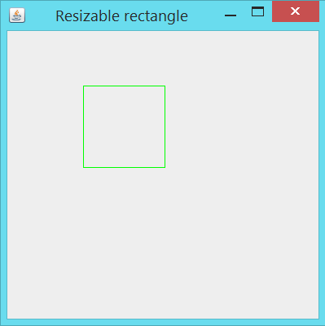

During a drag of bottom or right side:

